DAILY ONLINE ACTIVITIES SUMMARY
Date: |  | 11/06/2020
Name of the Faculty |  | Ankitha Shetty
No. of Students Allotted for monitoring |  |  |  | 16
Progress |  |  |  | Good
Whether collected report from all the allotted students |  |  |  | 12 students are updating daily  2 students are involved in online activity.  2 students are not uploading anything.
Online Test Summary
Subject
Semester |  |  |  | Duration
No. of students Taken |  |  |  | Passing %
Certification Course Summary
Course |  | - Applied machine learning using python  - Workshop on Technical Document Preparation using Latex.  - FDP on PERL scripting
Certificate Provider |  | - NMAMIT Nitte  - Dr. S. & S. S. Ghandhy Government Engineering College, Surat.  - Lords institute of engineering and technology, in association with IIT Bombay |  | Duration |  | 2 hours
Coding Challenges

Problem Statement: Python program to implement perfect sum problem

Status: 35 students
Uploaded the report in Github |  |  |  | Yes
If yes Repository name |  |  |  | https://github.com/ankishetty91/ankitha-daily-report
Uploaded the report in slack |  |  |  | Yes

Certification Course Summary
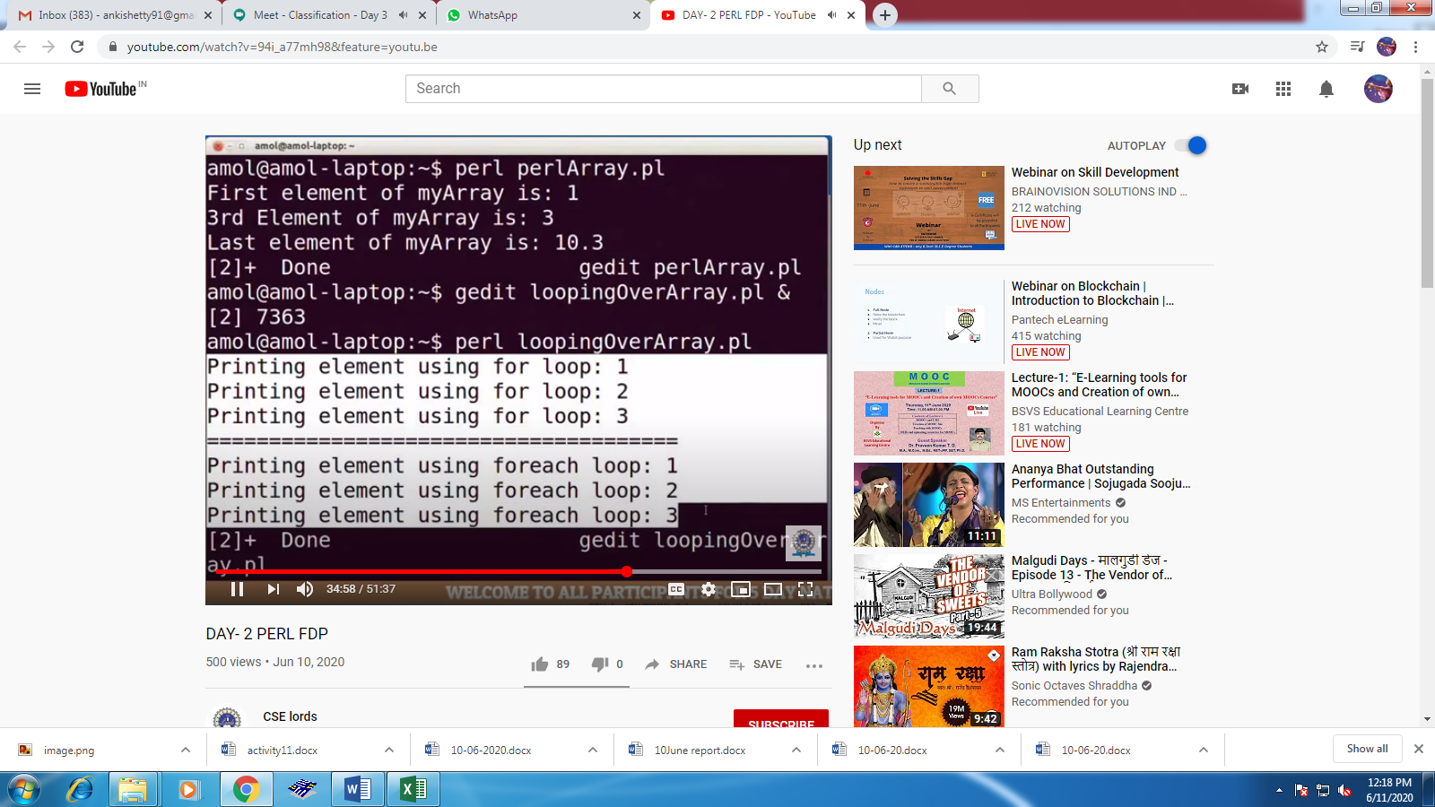

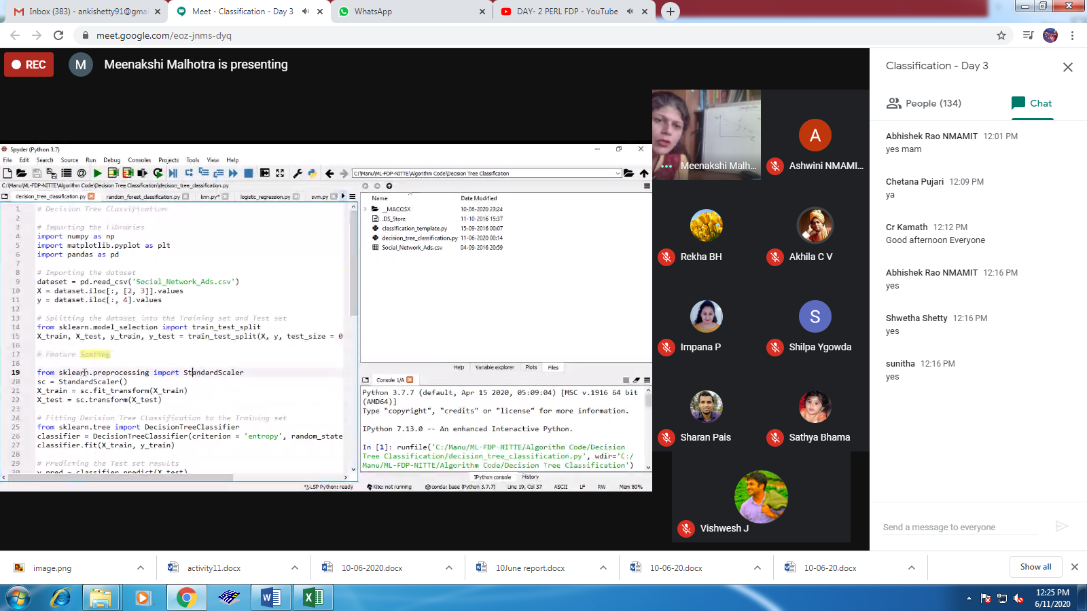

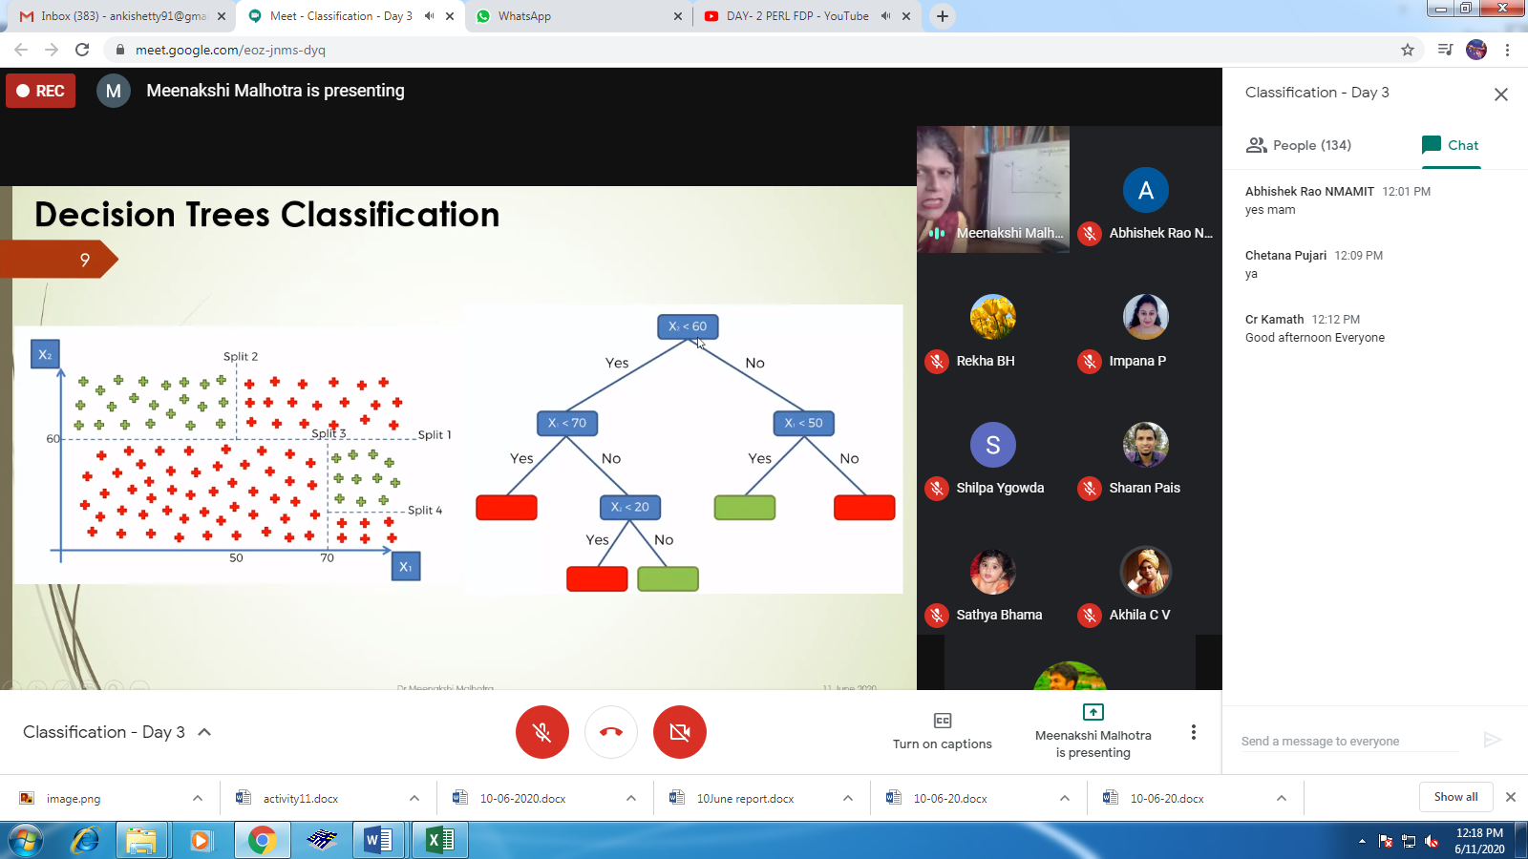

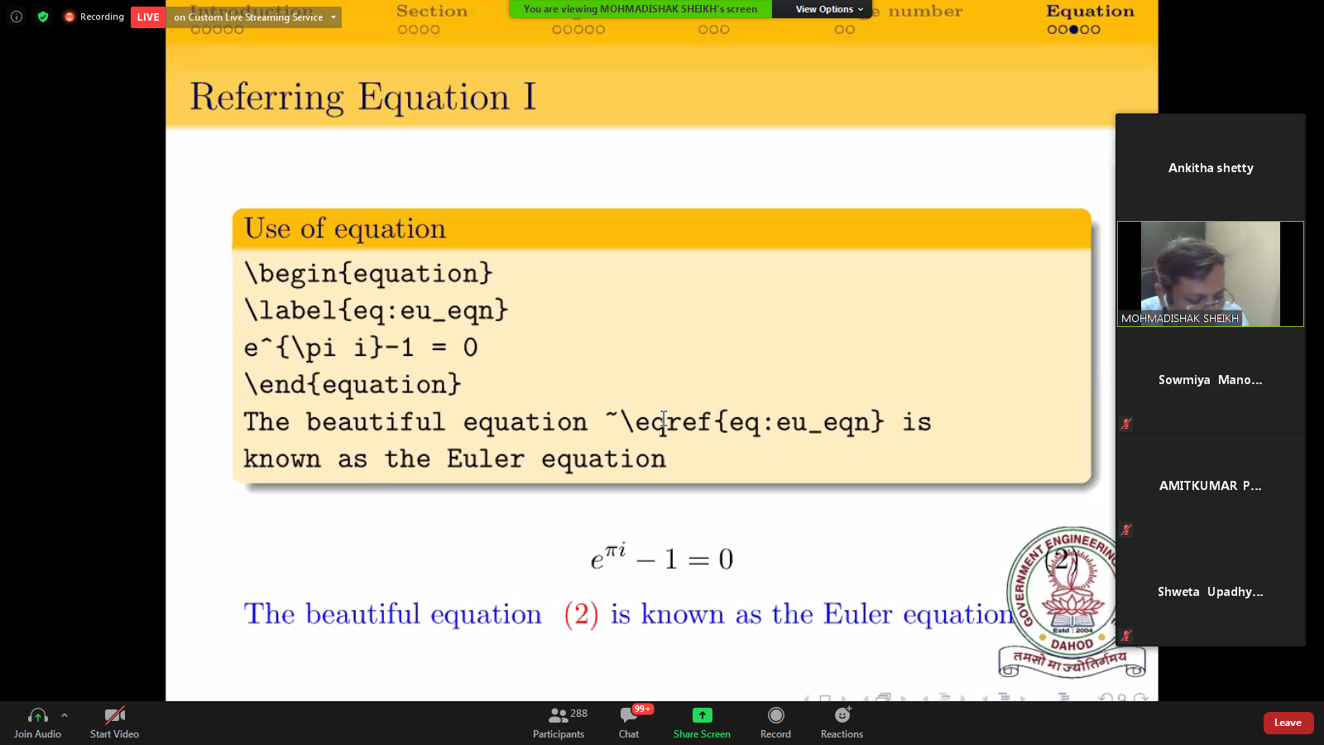

Students Report:

